Final Project

Design Document

By Meredith Rosser for CSC221 Final Project

Introduction 2

Project Functionality 2

Design Process 2

Project Development 2

Pseudocode 2

Flowchart 2

Requirements 3

## Introduction

### Project Functionality

The goal of my snake game is to eat as many pieces of fruit as possible without colliding with the borders of the game and without turning back into the snake itself. There will also be a play button at the very beginning, as well as a restart button when the player fails.

### Design Process (WIP)

I have been using Chapter 5 of the Brookshear text as well as the tutorials on PyGame and the library tools on the site.

## Project Development

### Pseudocode (WIP)

I am currently in the process of redoing my code, as the snake was not consuming fruit or expanding.

### Flowchart (WIP)

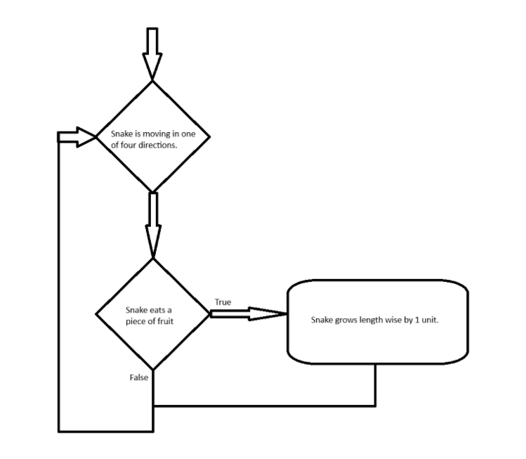

### Requirements

1. Board Size/ Play Area:
   1. My game is currently running on a 15x15 tile set.
2. Snake Movement:
   1. The snake moves continuously in each direction, and can be controlled by the arrow keys as well as w, a, s, and d.
3. Snake Growth: (WIP)
   1. I have not been able to successfully get the snake to grow once eating the fruit.
4. Food Generation: (WIP)
   1. Currently the food does randomly appear at the beginning of the game, but it does not go away once eaten.
5. Collision Detection:
   1. The game does successfully end if the snake runs into a border or itself.
6. Game Over and Score: (WIP)
   1. I have not been able to create a game over and score screen yet.
7. Restart Option: (WIP)
   1. I have not been able to create a replay button yet.